**FACULTY RESEARCH AND DEVELOPMENT RESEARCH**

*Prezi*

Navigation

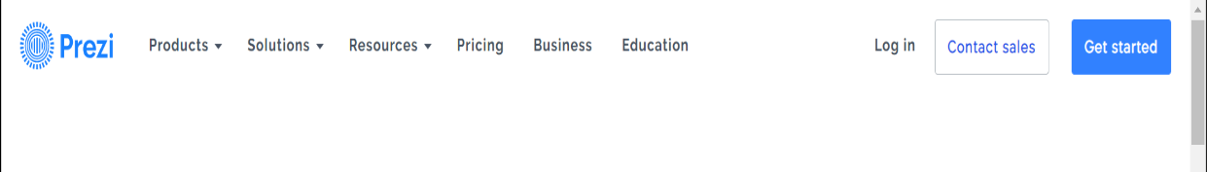

* Navigation bar stays on top of every webpage making it easy to drive to any other webpage.
* Navigation bar is plain and simple, so it does not interfere with webpage content.
* Hyperlinks for related webpages are clustered under one button with a dropdown symbol ˇ
* Website symbol takes you directly to home page

Interaction and aesthetics

* Interactive buttons on website
  + Buttons have transparent pop-up features explaining the use of the buttons with a smooth pop-up
  + Transparent nimbus protruding from more significant buttons (giving a **press me** impression)
  + Buttons have bold colours and light shadows making them stand out from the rest of the page as being ‘pressable’
  + Button moves up and down slightly (like an actual button) when pressed
* Interactive video frames on website
  + When hovering over video frame (These features were recently added to YouTube):
    - Frame enlarges slightly
    - Text under frame is highlighted
    - Video previews without sound for a few seconds
  + Video can be played from the frame and can be enlarged